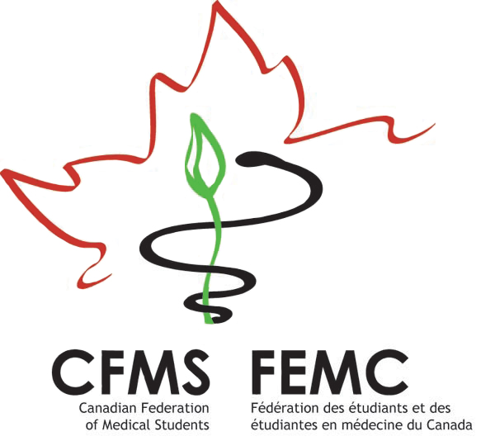
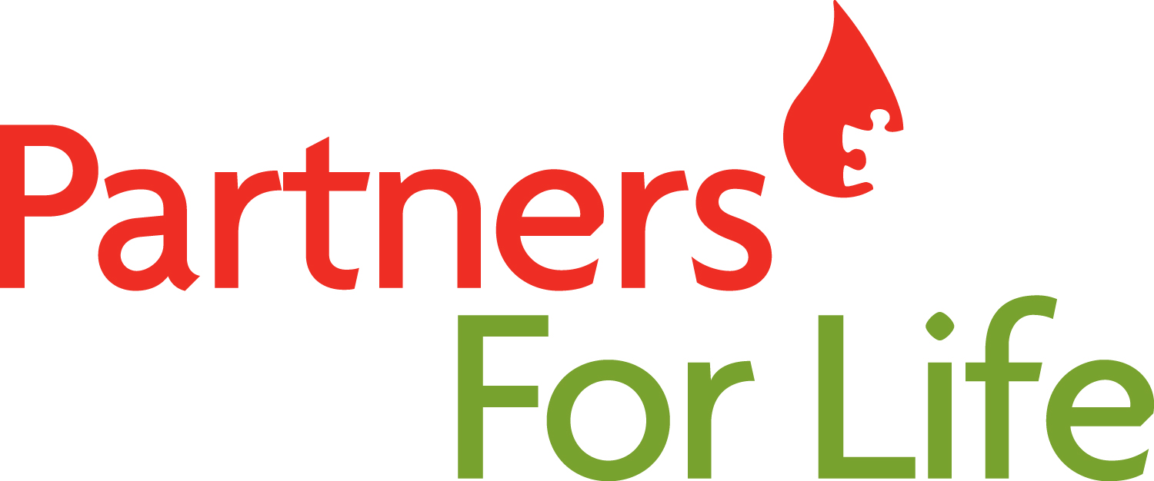



The 3rd Annual Phlebotomy Bowl!
September 1 – February 29

It’s time for the start of the 2015-2016 annual Phlebotomy Bowl!

Last year’s challenge was an amazing success – bringing in a total of 751 life-saving blood donations and a total of 105 new blood donors. Congrats to the top schools in 2014-15:

- Most Donations Per Capita: Dalhousie Medicine New Brunswick
- Most New Donors: University of British Columbia – Vancouver
This year’s challenge runs until February 29, 2016. Our goal is to contribute at least 800 donations, including at least 100 first-time blood donors. We’ll compete for two prizes again – one for the most donations per capita, and one for the most first-time donors. The winning schools will have their name engraved on their respective plaque which they can proudly display at their school for the year! This way, you get recognition and bragging rights for years!

Here’s how you can help your school win:
- Download the GiveBlood App or visit blood.ca to find your nearest blood donor clinic and book your appointment to donate. Also watch for information about a donation campaign organized by your school’s Champions. Giving blood takes about an hour and you can donate every 56 days. Donate in September or October and you’ll have time to make three donations during the challenge!
- The only way your donation will count towards the bowl is if you are registered under your school’s Partners For Life number. Visit www.blood.ca/joinpartnersforlife and register with your school’s Partner ID number listed below. This is a one-time registration. Once you register, your past and future donations will automatically count toward your school.

The Phlebotomy Bowl is all about inclusivity, therefore everyone can participate. If you’re not eligible to donate yourself, consider recruiting another donor, a friend, a collegue or a non-med student, to give blood on your behalf. Or help spearhead our partnership with Canadian Blood Services at your school. We’re still looking for more champions – especially first-year students to help out. Contact salima.abdulla89@gmail.com.

When you donate this September, you’ll also be helping to mark Childhood Cancer Awareness Month. Did you know that on average, it can take up to five blood donors to help one child undergoing cancer treatment and up to eight donors a week to help a child with leukemia? 1,500 children are diagnosed with cancer each year, and over 1,500 new blood donors are needed each week across Canada. Each new blood donor can change the life of a child who is fighting cancer.

Show your support for families affected by childhood cancer, save a life and help your school win the Phlebotomy Bowl by giving blood this fall!

If you have any questions or would like more information about the Phlebotomy Bowl, please do not hesitate to contact me!

Salima Abdulla
salima.abdulla89@gmail.com
CFMS National Blood Drive Officer
MD Candidate, Class of 2017
Faculty of Medicine
University of British Columbia

Medical School | Your school’s Partner ID (four letters, six numbers)
University of British Columbia – Vancouver | CANA009068
University of British Columbia – Island Medical Program | CANA008664
University of British Columbia – Southern Medical Program | CANA014519
University of Calgary | CANA008454
University of Alberta | CANA008957
University of Saskatchewan | CANA003644
University of Manitoba | CANA008366
University of Western Ontario | CANA008379
McMaster University | CANA008306
University of Toronto | CANA008763
University of Ottawa | CANA009110
Northern Ontario School of Medicine – Sudbury | CANA008344
Queen’s University | CANA004228
Dalhousie University – Halifax | DALH009044
Dalhousie Medicine New Brunswick | CANA012634
Memorial University | CANA008882

